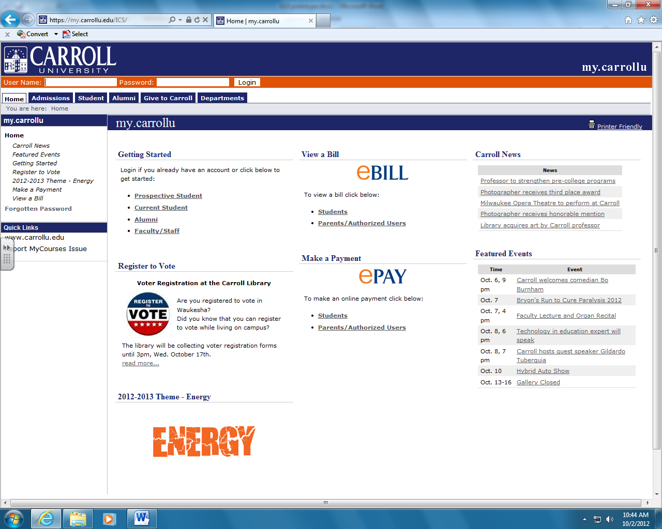

|  |  |
| --- | --- |
|  | |
| User name Password  Login | |
| Help  Home  Administration | |
| You are here: Home | |
| Assets |  |
| Videos  Pictures  Documents  Sounds |
| Quick Links |
| www.carrollu.edu  my.carrollu.edu  ITS |

|  |  |
| --- | --- |
|  | |
| Welcome back **User** ( *Personal Info* | *Logout*) | |
| Help  Home  Administration | |
| You are here: Home | |
| Assets | Search | Advance |
| Videos  Pictures  Documents  Sounds |
| Quick Links |
| www.carrollu.edu  my.carrollu.edu  ITS |

|  |  |
| --- | --- |
|  | |
| Welcome back **User** ( *Personal Info* | *Logout*) | |
| Help  Home  Administration | |
| You are here: Home | |
| Assets | Search | Advance |
| Videos  Pictures  Documents  Sounds |
| Quick Links |
| www.carrollu.edu  my.carrollu.edu  ITS |

|  |  |
| --- | --- |
|  | |
| Welcome back **User** ( *Personal Info* | *Logout*) | |
| Help  Home  Administration  Search | |
| You are here: Home | |
| Assets | (TBA) |
| Videos  Pictures  Documents  Sounds |
| Quick Links |
| www.carrollu.edu  my.carrollu.edu  ITS |

|  |  |
| --- | --- |
|  | |
| Welcome back **User** ( *Personal Info* | *Logout*) | |
| Help  Administration    Home  Search | |
| You are here: Home | |
| Assets | (TBA) |
| Videos  Pictures  Documents  Sounds |
| Quick Links |
| www.carrollu.edu  my.carrollu.edu  ITS |